|  |  |  |  |
| --- | --- | --- | --- |
|  | |  | |
|  |  |  | | **ANNUAL INTERNATIONAL**  **WOMEN’S CONFERENCE**  **EAST AND WEST MEET IN SAINT PETERSBURG**  **ill be held** | | **FullSizeRender.jpg** | |  |  |  |

**will be held on 17-18 November 2016 under the auspices of the Government of Saint Petersburg and in cooperation with International Ratings Center**

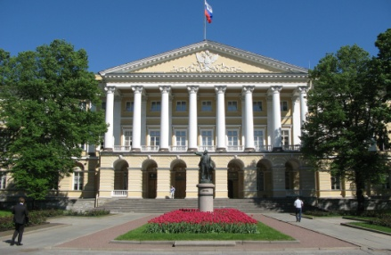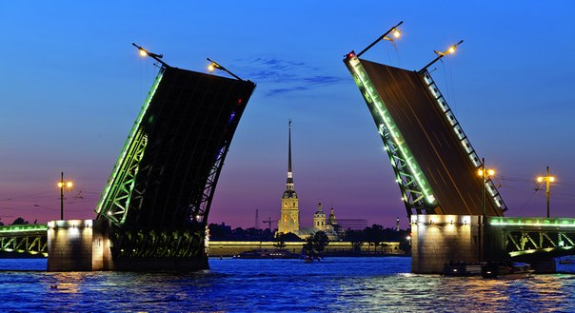

The major topic for discussion at the 2016 Conference is

**Cooperation of Business Women – New Opportunities for the World.**

The Forum will create prerequisites for business women from regions of Russia, countries of Asia, America and Europe to join their efforts for development of business contacts providing the basis for sustainable development of the society in the contemporary conditions of instability, wars, terrorism, and economic crises.

At the time of crises and wars it is women that take up the responsibility for the destinies of the family, children, and old people. In such conditions the traditional gender roles change, and new possibilities are to be created for women to become more mobile and to have new resources in their communities. It is necessary to work out political and economic mechanisms enabling women to influence the policy of government support of entrepreneurship, to combine professional and family duties, to maintain active interregional and international cooperation. The International Women’s Conference “East and West Meet in Saint Petersburg” is a forum for constructive discussion of the existing problems and sharing of the best practice of different countries in issues of the quality of women’s life, problems of their discrimination in the economic sphere, including access to resources, finances and property, for creation of regional and international business networks. Within the framework of the conference the participants will have a number of meetings in the Governments and Legislative Assemblies of Saint Petersburg and Leningrad region, the Chamber of Industry and Commerce, other organizations and institutions, city enterprises in accordance with their interests and by prior requests.

Key issues for discussion at the Conference in 2016:

* Women – “soft power” and driving force of people’s diplomacy;
* Social-economic status of women in the conditions of a crisis, their place on the labour market ;
* Support of women’s entrepreneurial activities – experience of the best and possibilities of international and national financial and credit institutions;
* Innovative forms of support of women’s entrepreneurship;
* Problems of immigrants involvement in economic processes: new developments in the labour and migration legislation;
* “Women’s” spheres of entrepreneurship and creation of regional and international business networks in:

- tourism, organization of recreation and health improvement,

- production and sales of souvenirs and items of arts and crafts,

- light industry and design,

- innovations in agriculture: development of chains of manufacture of foods and food processing industry,

- organization of non-state forms of education,

- ”green” business,

Аnd others.

The Conference will be accompanied by Women’s Project exhibition of women entrepreneurship at which the interested participants will be able to present samples of their products and speak about the provided services and achievements.

Representatives of executive and legislative authorities, non-governmental organizations, mass media and educational institutions, experts, directors of companies and entrepreneurs are invited to take part in the forum.

The opening and sectional sessions of the Conference will take place on **November 17, 2016, business meetings will be held on November 18, 2016.** The completion of the Conference on **November 19, 2016** will be followed by the celebration of the International Day of Women-Entrepreneurs (Participation at one’s will).

The cost of participation in the Conference is 300 $ US (VAT exempt) and includes participation in all events of the forum, the participant’s folder, interpreting, 2 lunches and 1 coffee break, reception on behalf of the Organizing Committee, transfer from the hotel to the venue.

**The Organizer of the Conference is Saint Petersburg Social and Economic Institute**

**Phone/fax +7 812 7171649, Phone: +7 812 7170711, +7 812 7175549**

**e-mail:** [**interweb@iwm.spb.ru**](mailto:interweb@iwm.spb.ru),

For detailed information and program see web-site: [www.iwmspb.ru](http://www.iwmspb.ru)